This assignment uses a GCU-provided virtual machine that will be specified by your instructor.

Databases are the engines behind the information age, from keeping track of your users to tracking millions of products for online retail websites. Structured Query Language (SQL) is the most common language of databases. Not all databases are developed with security in mind and may have input validation issues, which makes them the perfect target for an attacker.

1. Refer to "From SQL injection to Shell," found in the topic Resources, as a guide.
2. Using the GCU-provided virtual machine and "SQL Injection to Shell" VM from Vulnhub, perform an SQL recon and injection.
3. Document your findings under Phase Testing in the "ITT-340 PEN Testing Report Guidelines," located in Class Resources. Refer to "Writing a Penetration Testing Report," by the SANS Institute, located in Class Resources, for examples of PEN testing reports.
4. Append this assignment to the PEN testing report and resubmit the report (Passive Corporate Recon + Automating Information RECON + NMap Scan + Vulnerability Assessment + Applied Exploitation using Metasploit + Custom Payload + Website Vulnerability Assessment + SQL Injection).

While APA style is not required for the body of this assignment, solid academic writing is expected, and documentation of sources should be presented using APA formatting guidelines, which can be found in the APA Style Guide, located in the Student Success Center.

This assignment uses a rubric. Please review the rubric prior to beginning the assignment to become familiar with the expectations for successful completion.

You are not required to submit this assignment to LopesWrite.

Installed sqlmap

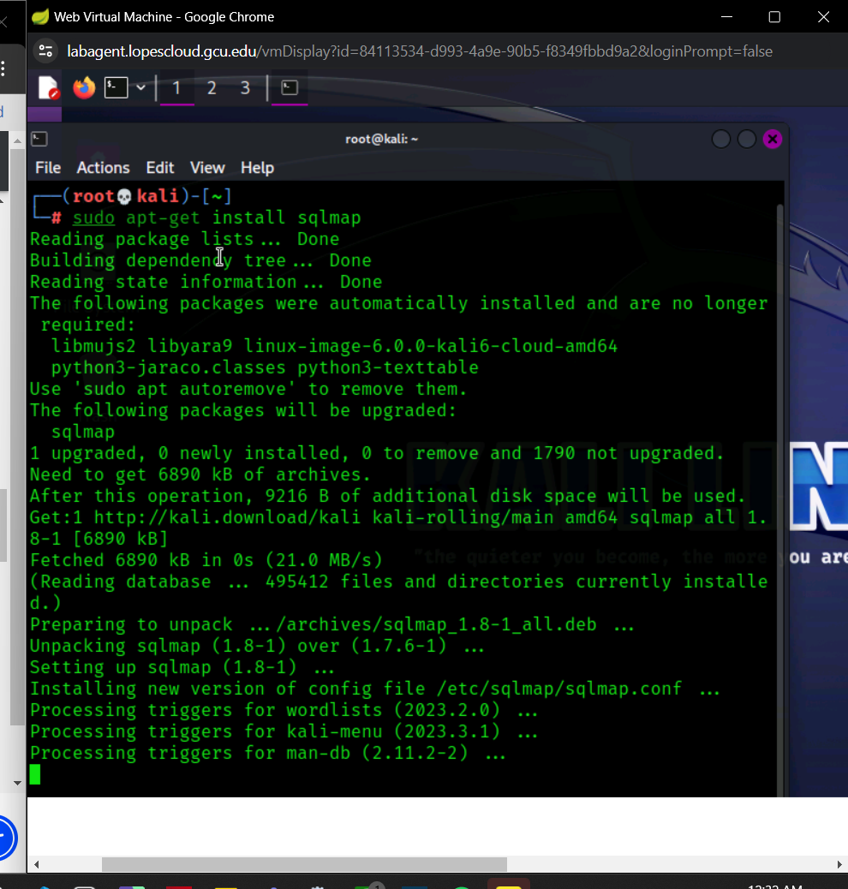

Went to the practice “vulnerable” site and took note of the url.

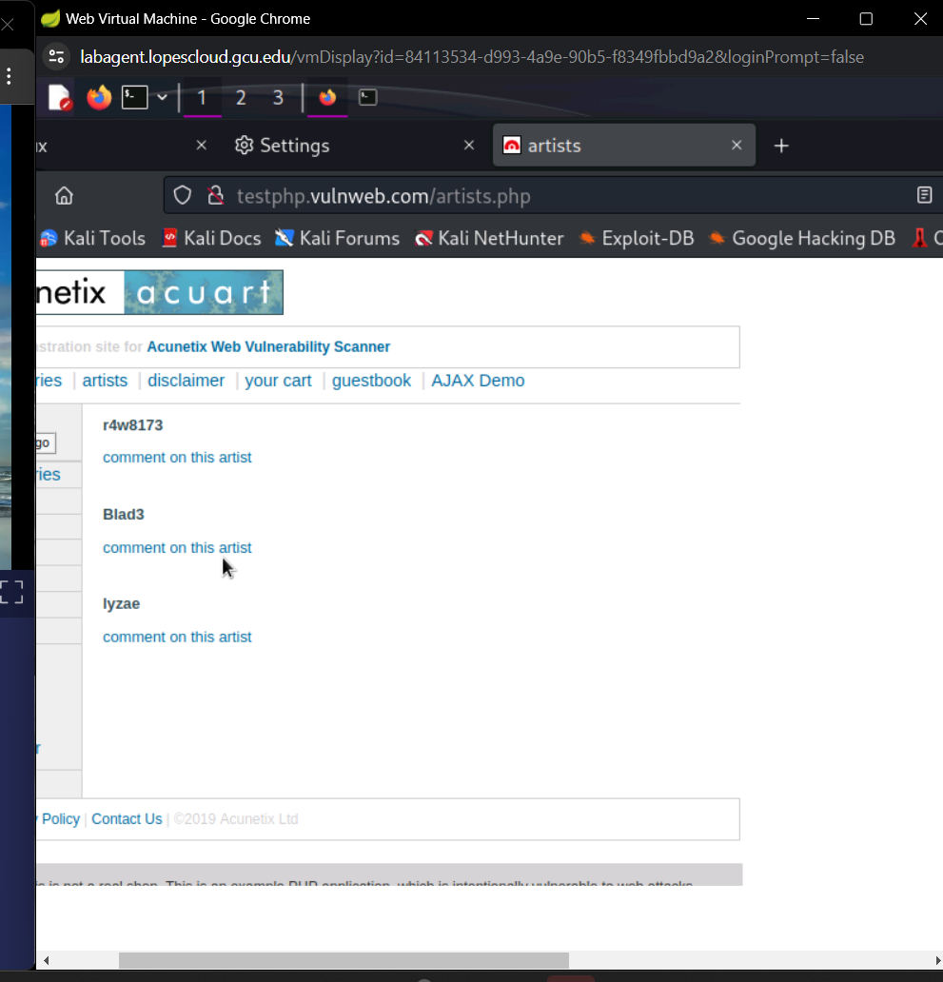

Opened the Help Menu in sqlmap in my cmd to get to know the different tools/functions specifically taking note of the Target functions.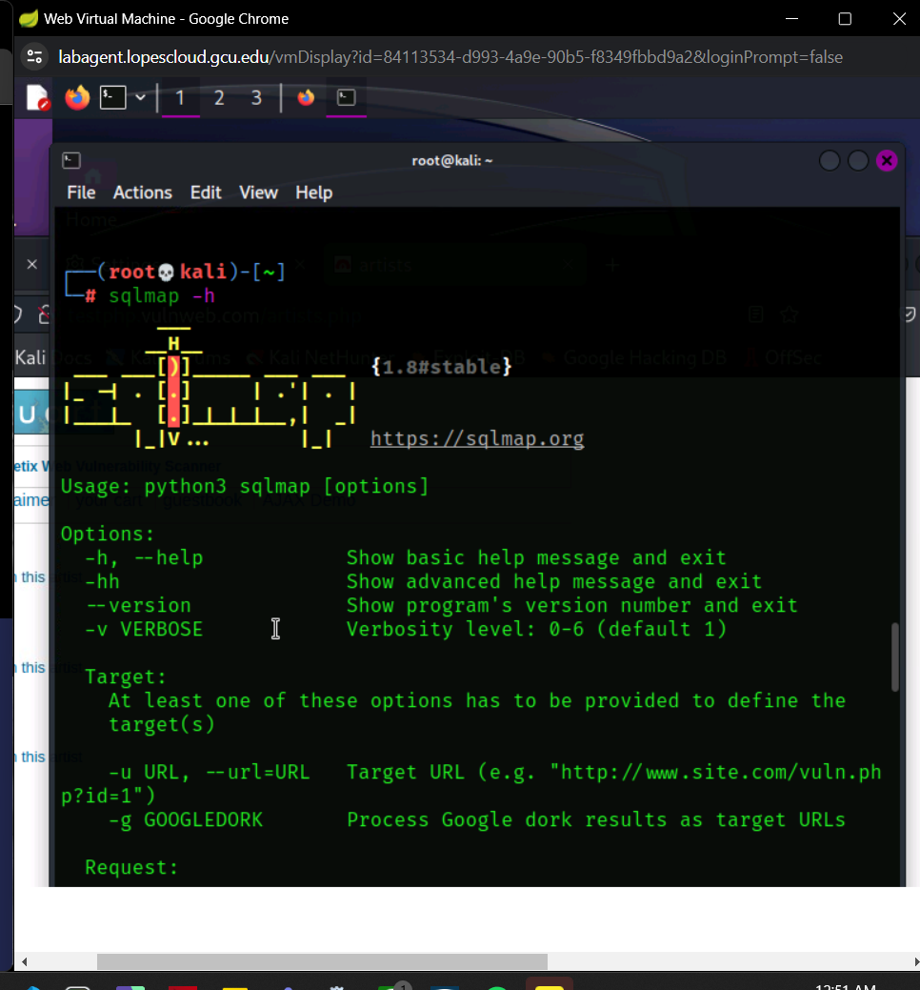

Utilized the website url then added additional code to access the database.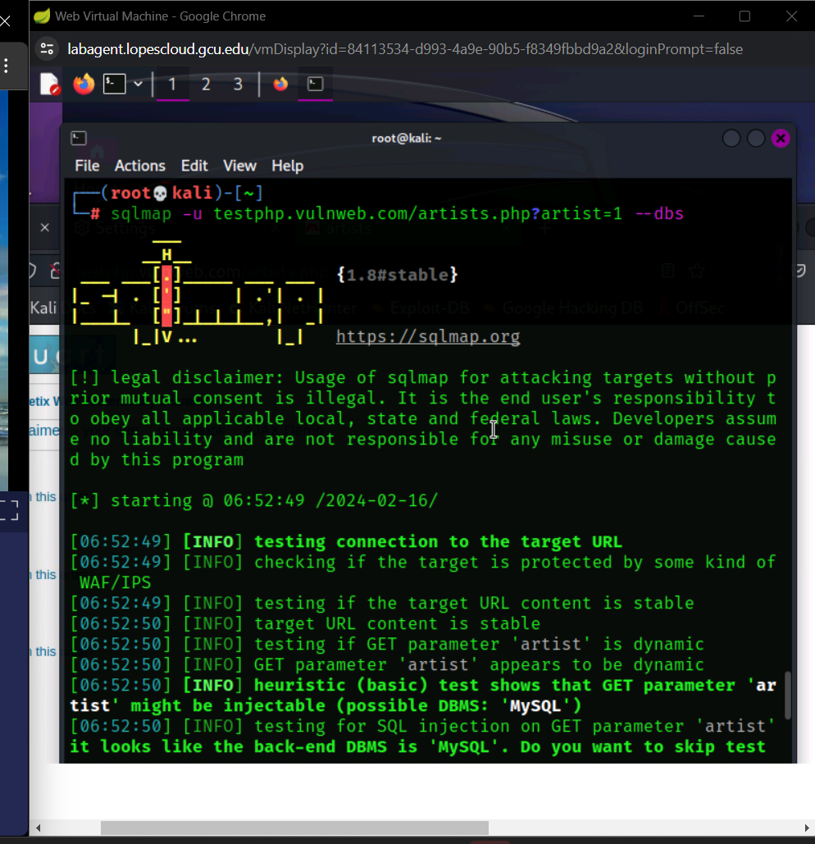

Replied Yes to skipping the test payloads and No to include all tests for MySqL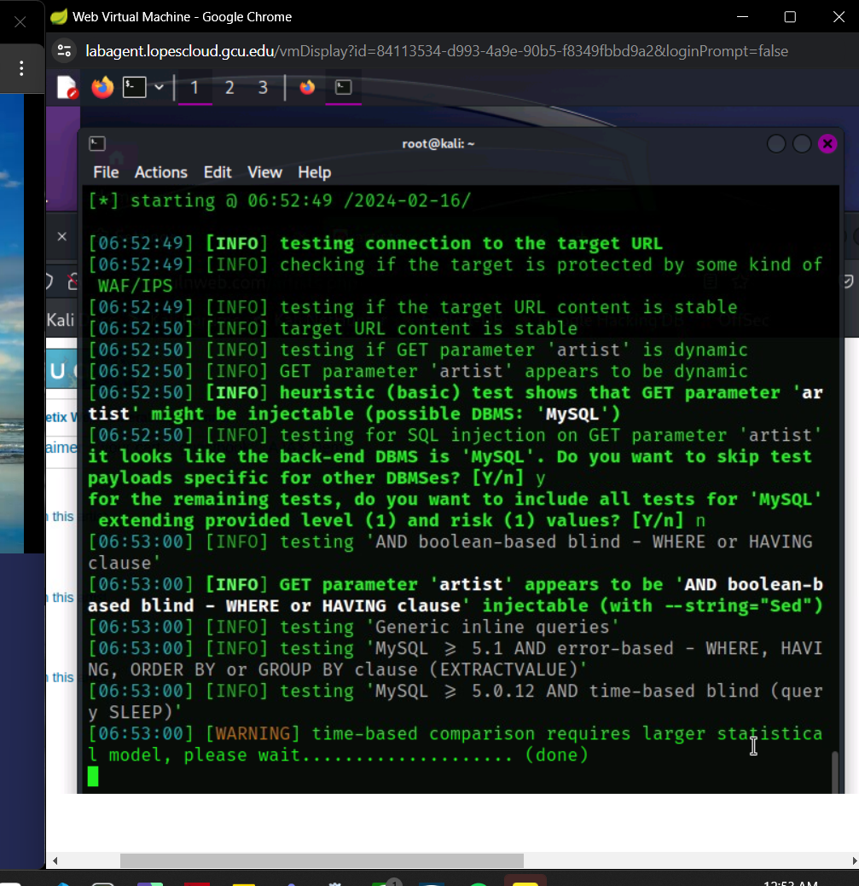

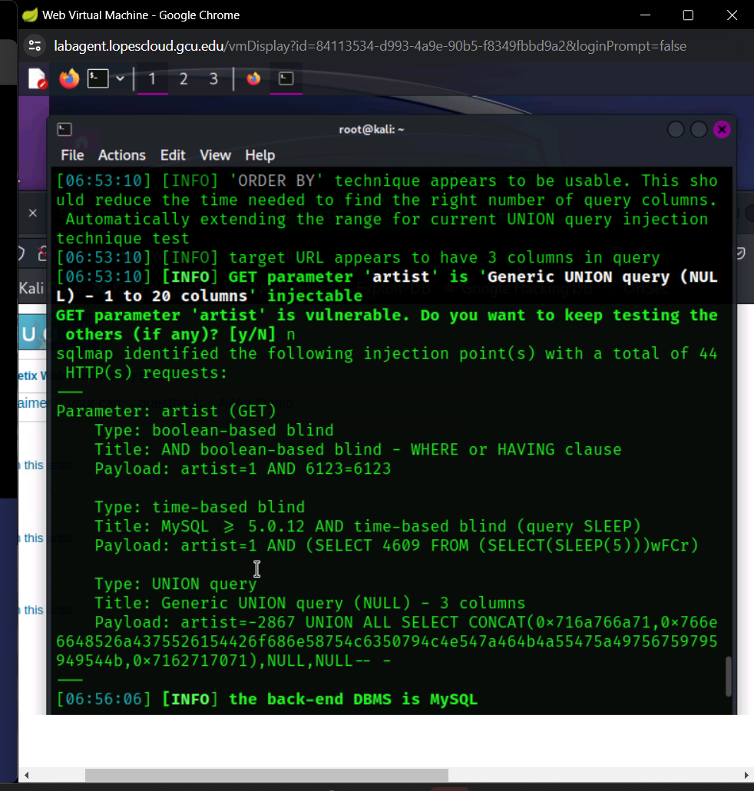

Discovered that Acuart is the file name for the database so we wanted to explore the tables inside it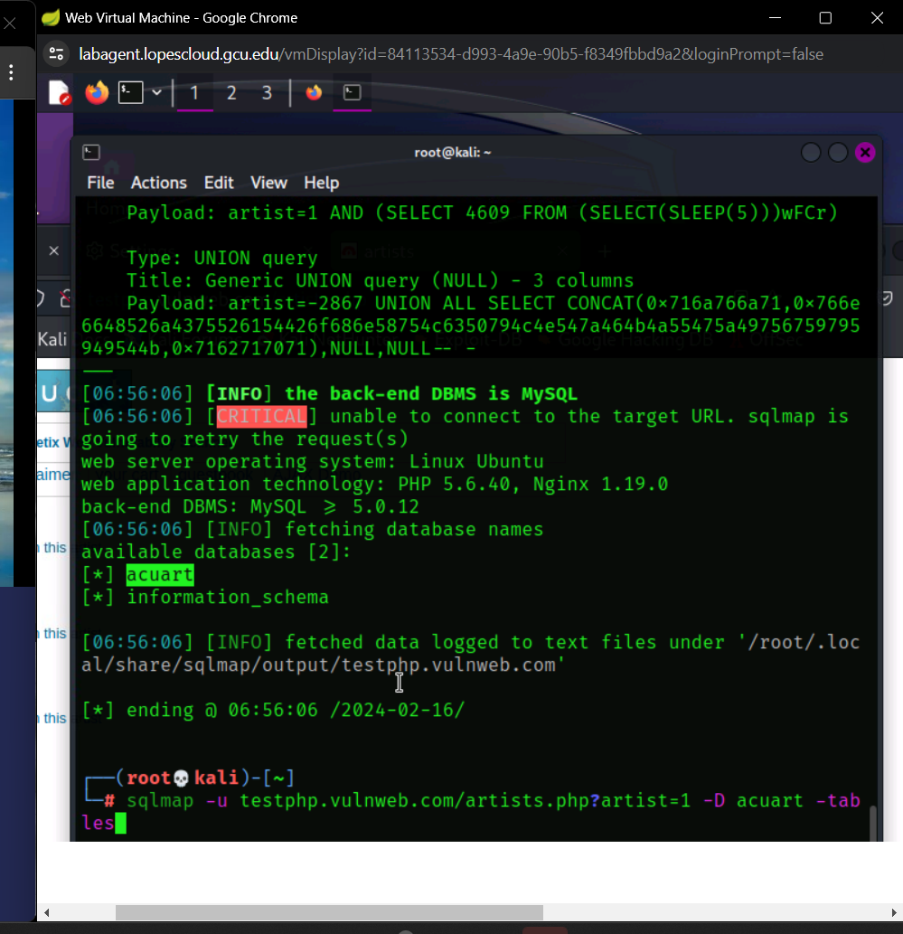

It revealed 8 categories to choose from, i then pursued the users column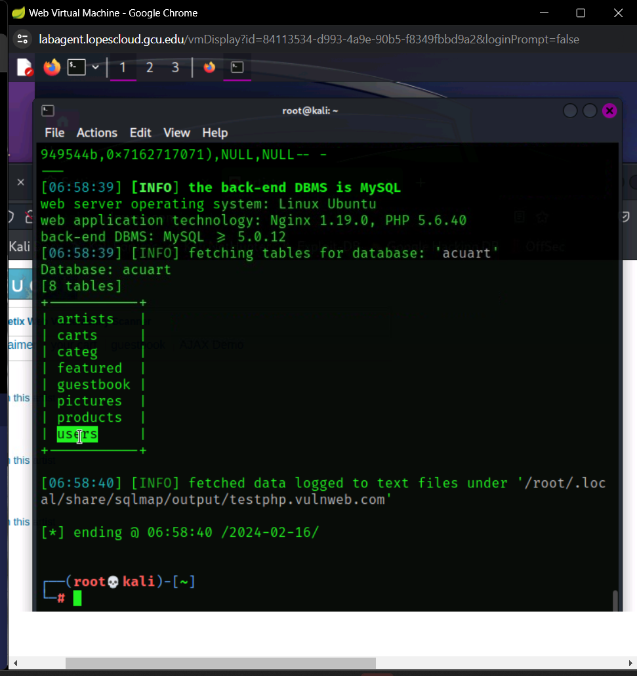

To enter the users column you enter the same url and code from previous and add -T for table and users then –columns to list all the info within the table for users.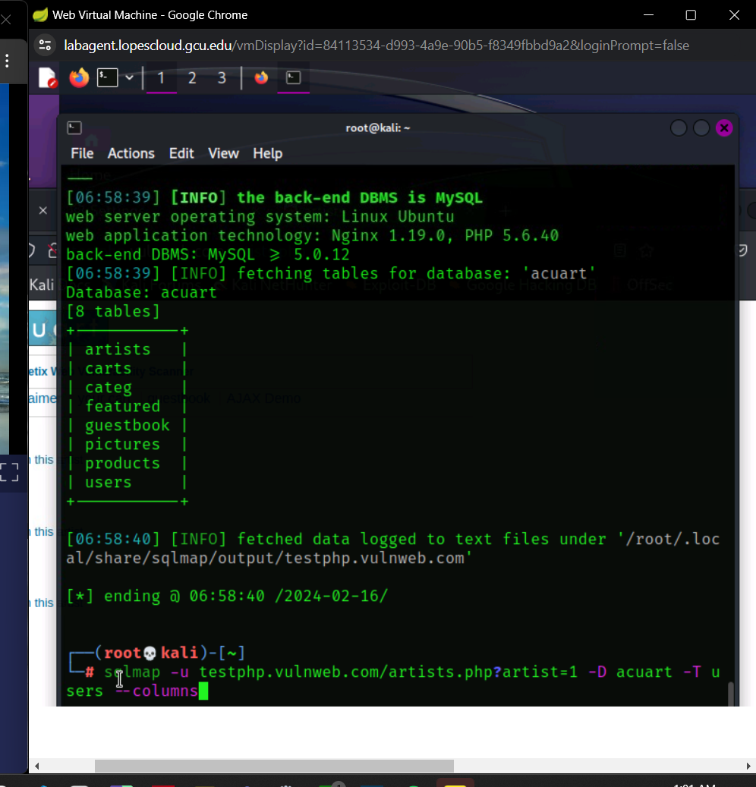

Which presented us with the following information:

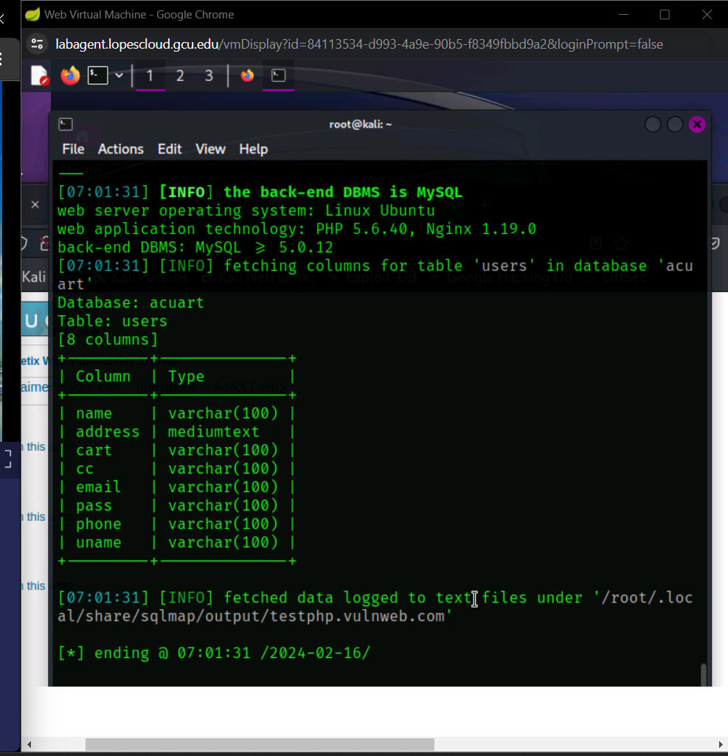To download the information from users enter the same first part of the url and code with –dump which will save it to the computer.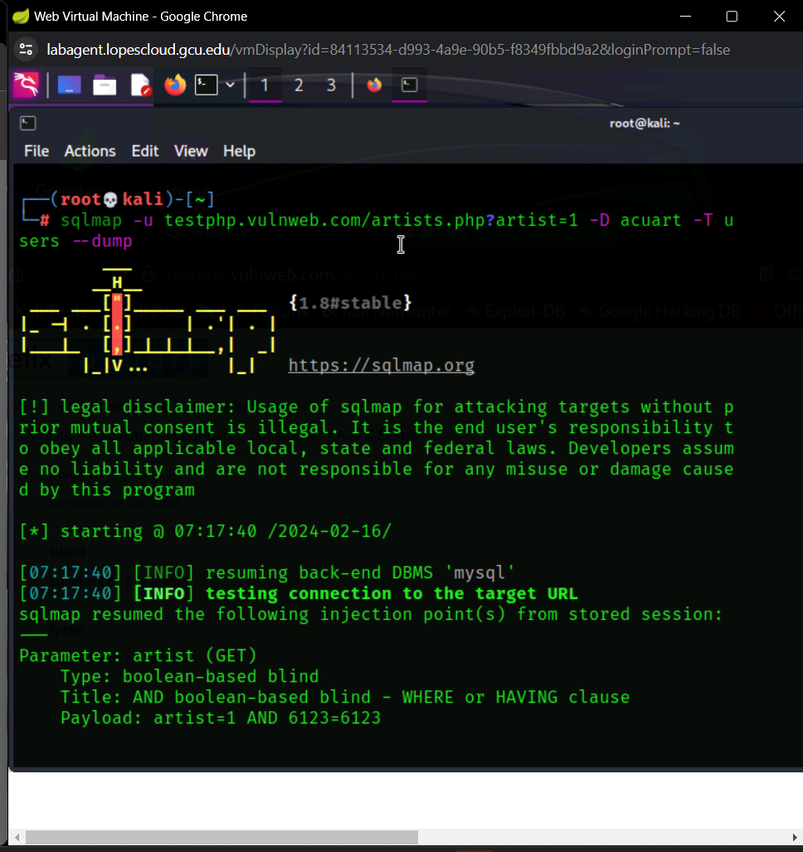

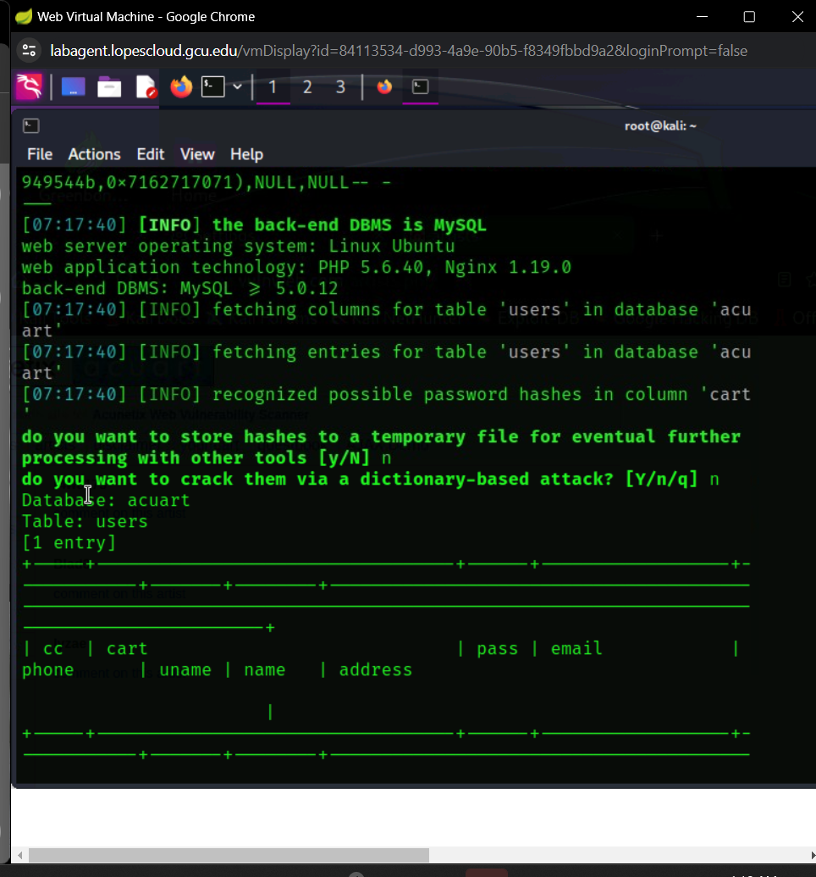It presents the exact file folder path which you can follow manually or open up file folder….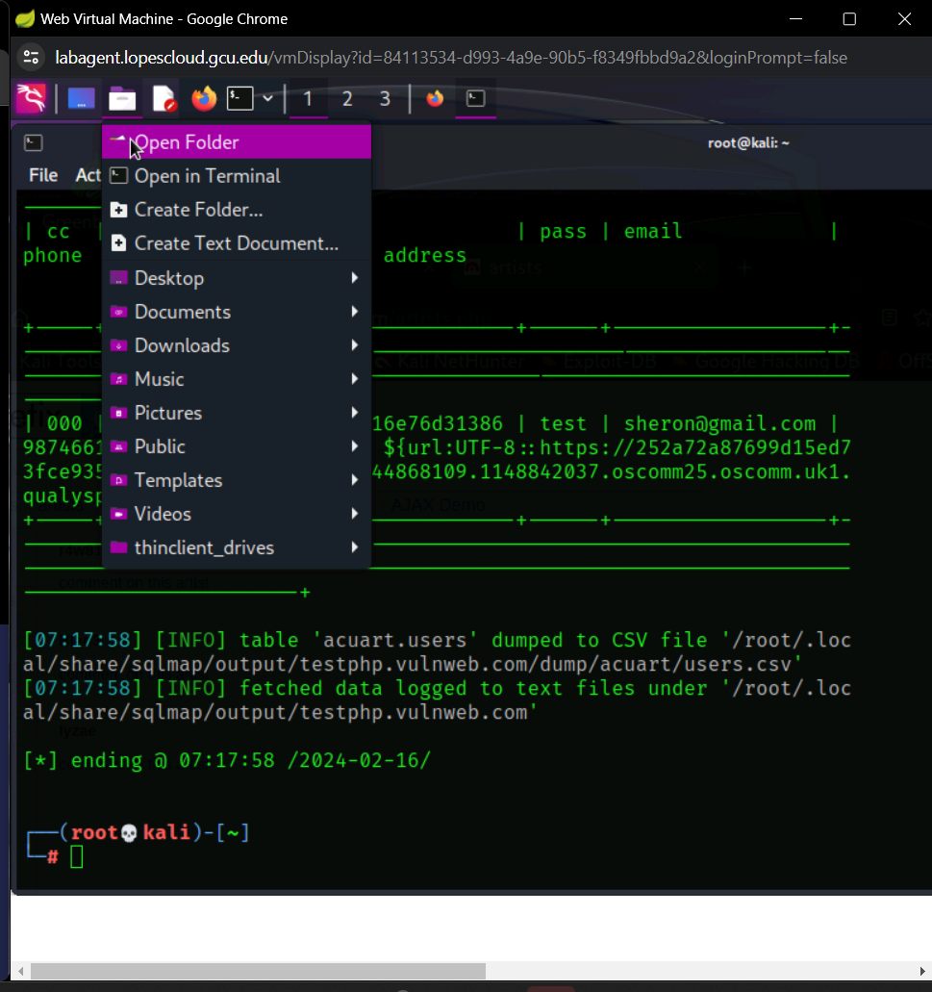

Go to the root folder and copy the file path directly.

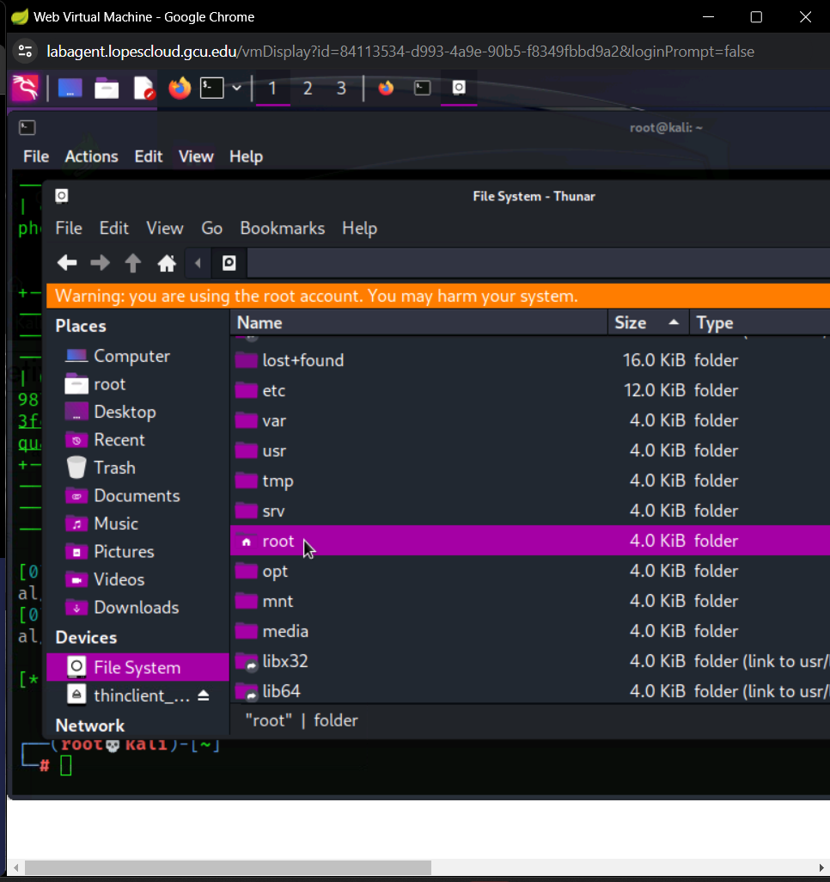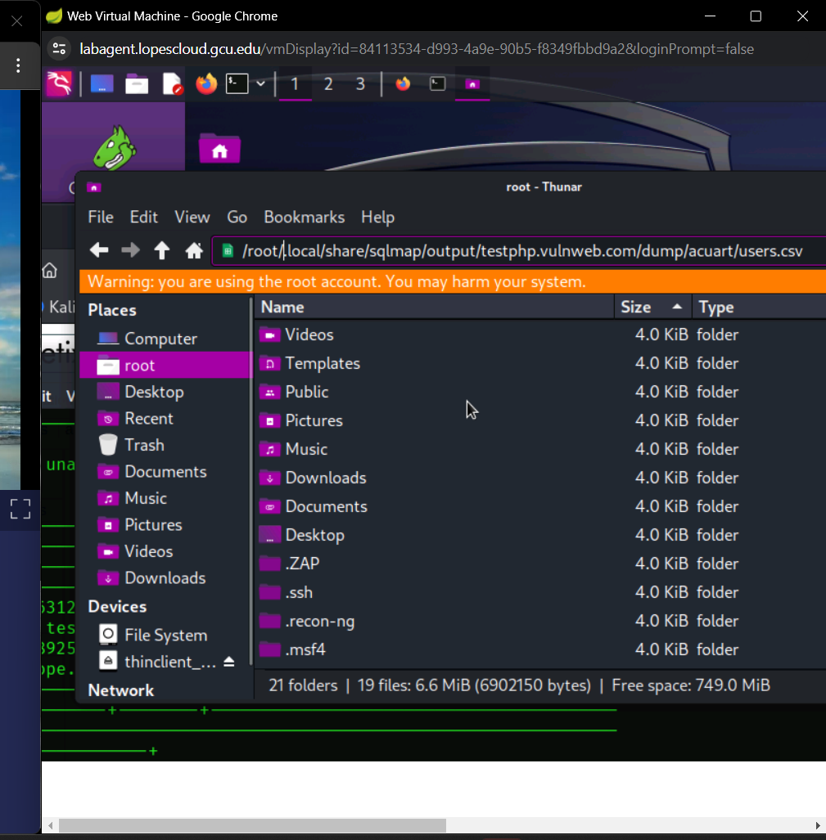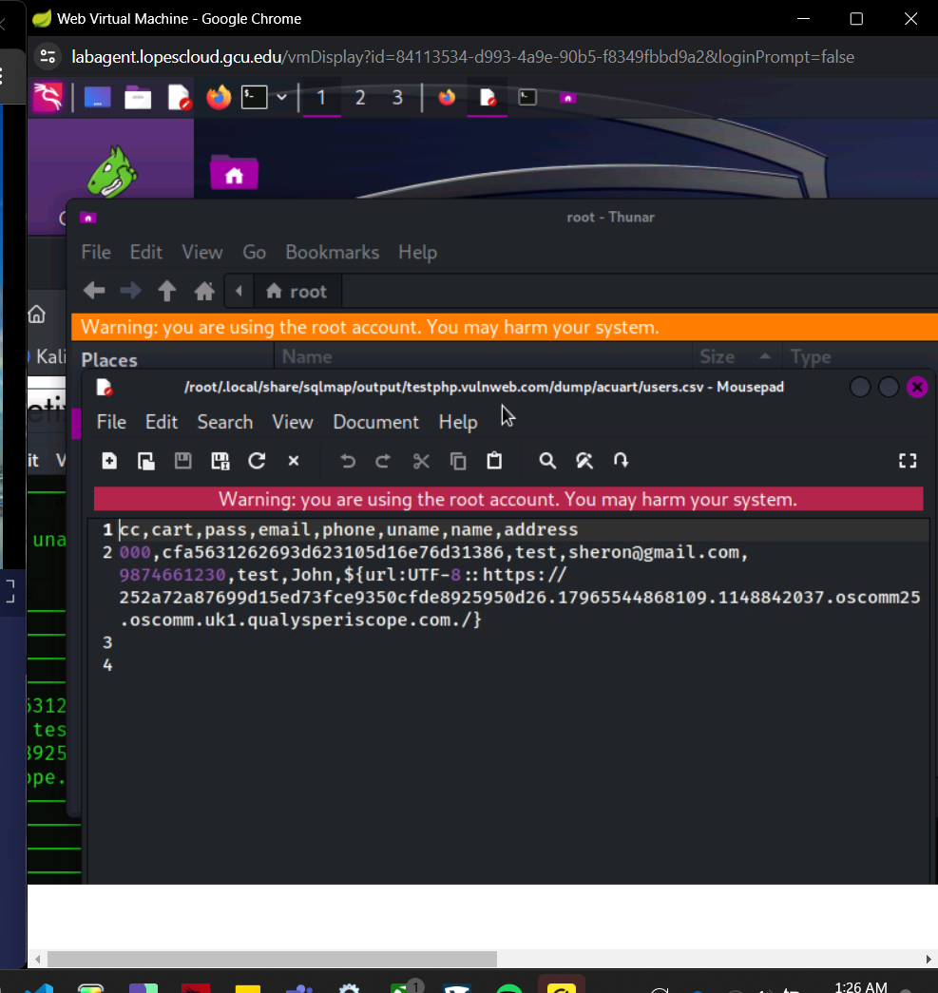

I repeated the same process again for the cart tables and to download that information to the computer.

